Notes on using the Arduino IDE to program the ATTiny85
July 20, 2026
USING THIS PROGRAMMER:
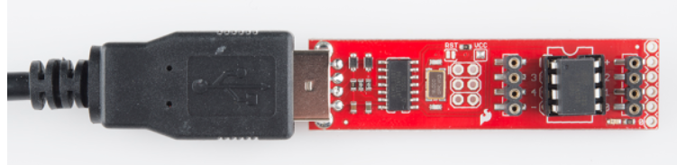
Unless this is a new Arduino install on the computer using to program, don’t mess with the pre-installed drivers. That is not the issue if it fails.
BUT, IF the drivers need to be updated, this works:
To use a SparkFun programmer (like the Pocket AVR or Tiny AVR) on Windows, download and install the Zadig driver installer. Plug in your programmer, open Zadig, select USBtinyISP from the dropdown, and install the libusb-win32 driver to establish the connection. [1, 2, 3]
Because SparkFun programmers generally fall into two categories (AVR Programmers or Boards with USB-to-Serial chips), the exact setup process varies:
1. AVR Programmers (Pocket AVR / Tiny AVR)
Used for burning bootloaders or programming raw chips via ISP. [1, 2]
- Driver: Windows will likely struggle to recognize this natively. Download and run Zadig, select libusb-win32 as the driver, and click Install Driver. [1, 2, 3, 4]
- Arduino IDE:
  - Go to Tools > Programmer and select USBtinyISP.
  - To upload code without a bootloader, click Sketch > Upload Using Programmer. [1, 2]
- Command Line: Uses avrdude natively. [1, 2]

With the correct drivers, the programmer (FabISP) will show up like this in the system devices list in the DEVICE MANAGER:
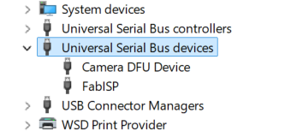

USING THE Arduino IDE to program:
SELECT THE FOLLOWING UNDER THE TOOLS TAB IN THE IDE:
- BOARD. Select “ATTiny25/45/85”
- PORT. Leave this alone!
- CLOCK: Select “Internal 1 MHz”. NEVER SELECT ANYTHING GREATER THAN 8 MHz
- PROCESSOR: Select “ATTiny85”
- PROGRAMMER: Select “USBTinyISP”
Load the program and select “Verify/ Compile” in the SKETCH tab. Then, with the programmer connected, select “Upload Using Programmer in the same tab. No errors should be apparent. LED flashes on programmer during programming. Takes about 3 seconds to program.

Background here:
Tiny AVR Programmer Hookup Guide - SparkFun Learn
Download | USBtinyISP | Adafruit Learning System

